**Show and Tell 3:**

**Viewport: to restrict player’s position in screen;**

1. Creat a Singleton class for viewport, cause viewport only have one instance in game;

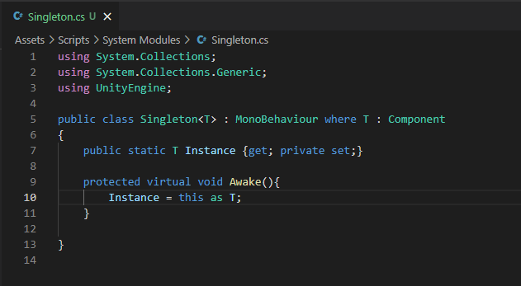

1. Creat a Viewport class and implement Singleton, limit camera in viewport

Add Viewport script to Environment

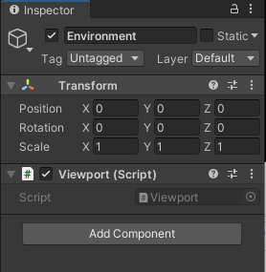

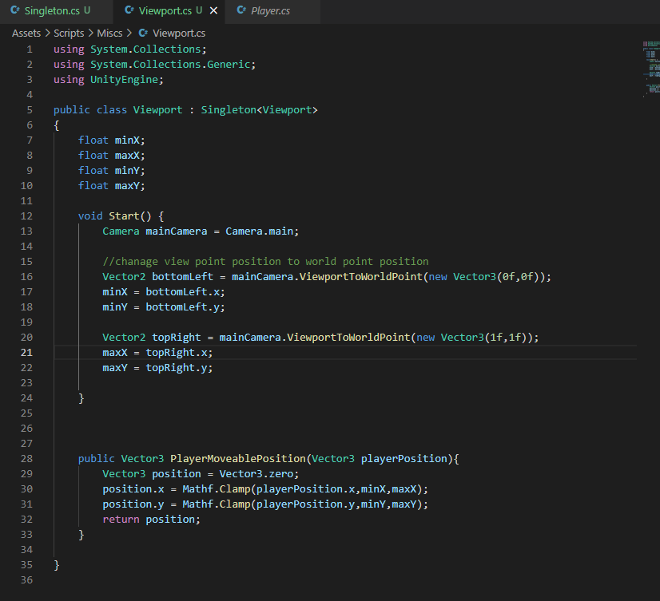

Write a function for player to limit positon

1. Add a Coroutine to update player’s position and limit it by moveable position function, start this coroutine when player move, stop it when player stop move.

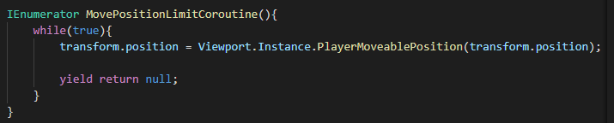

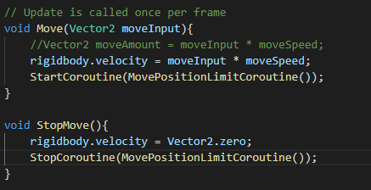

Then the player can be limited in screen

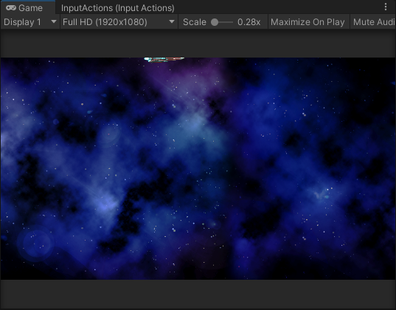

1. Add offset to position make player’s position more accurate

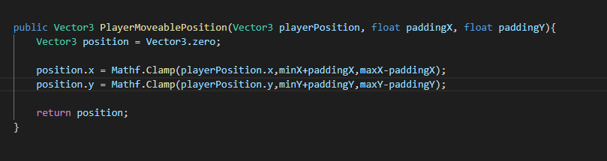

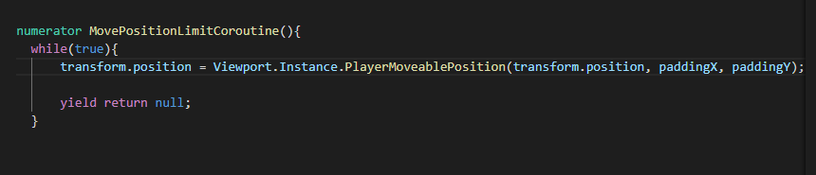

Now player’s position is more accurate

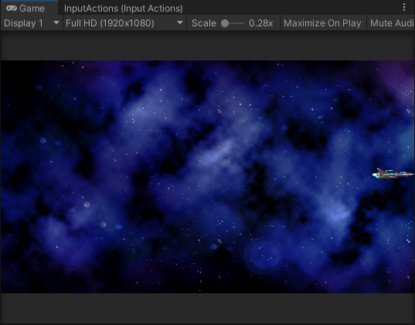

**Movement improvement: make player accelerate and slow down when moving, add rotation**

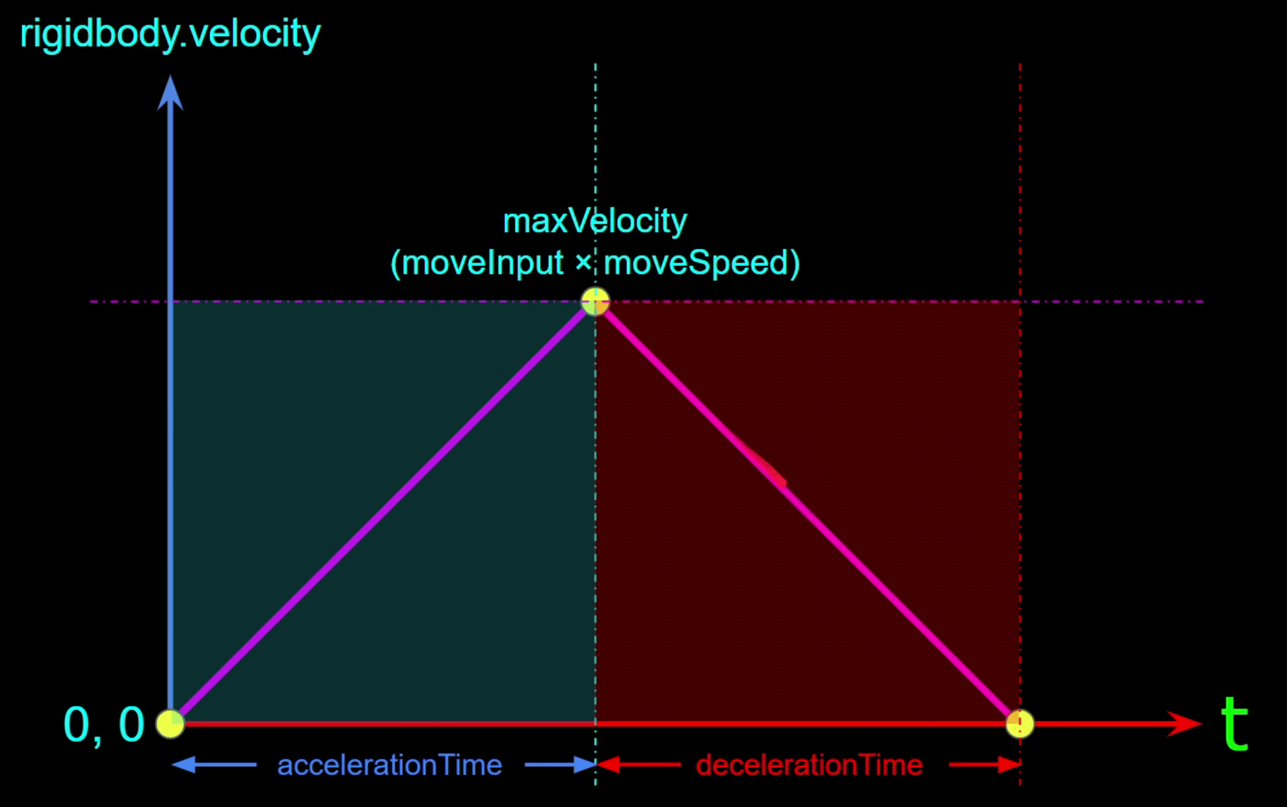

1. Add a coroutine to make speed increase evenly by time

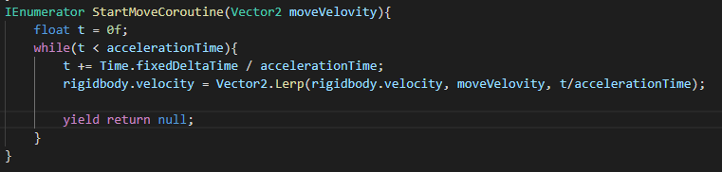

And same thing for decelerate

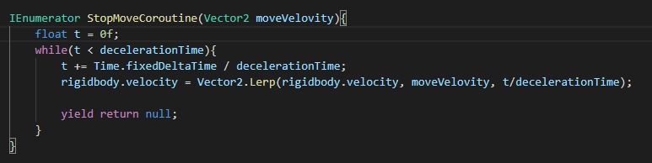

I combined them together

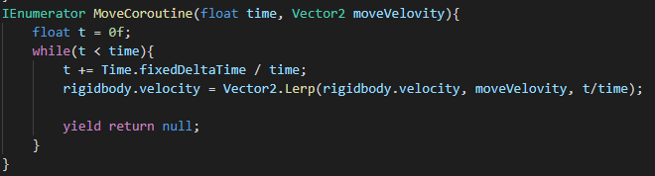

And start/ stop routine when move/stop move

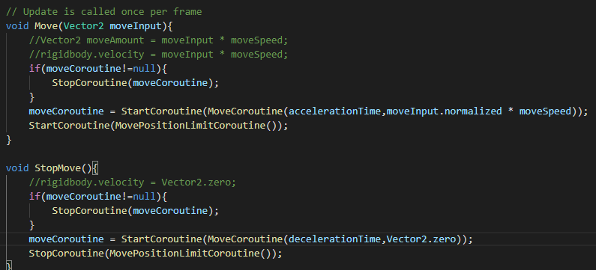

1. Add rotation

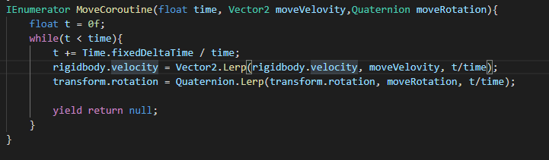

Use an angle and user input to calculate axis

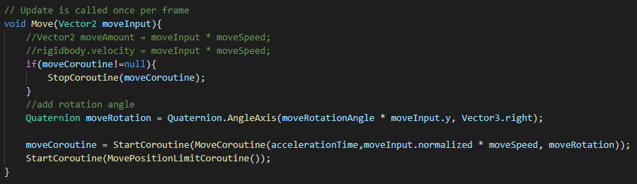

Then the player can rotate

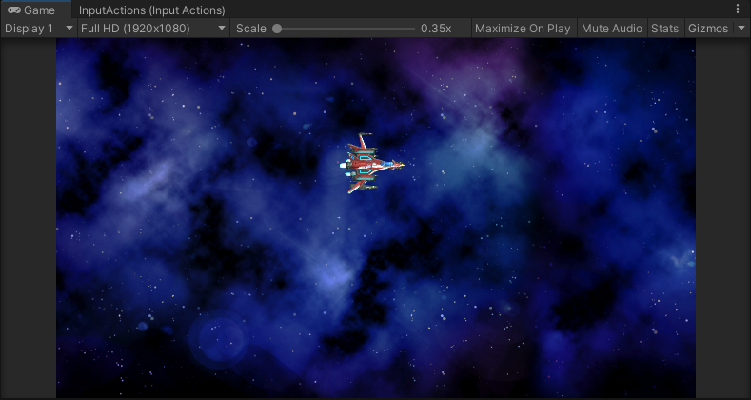

**Post Processing Volume, Bullet**

1. Set camera, enable post processing

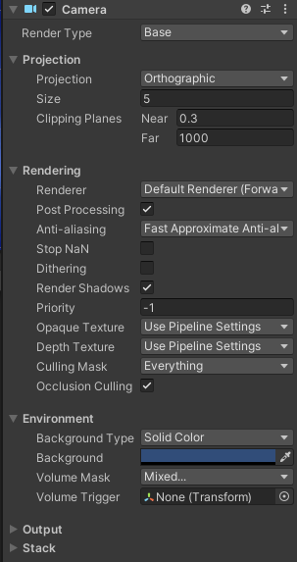

1. Add a bloom post processing

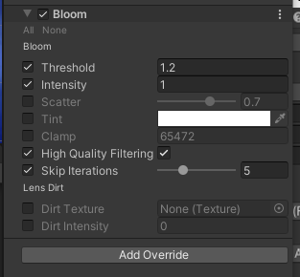

1. Add some other post processing:

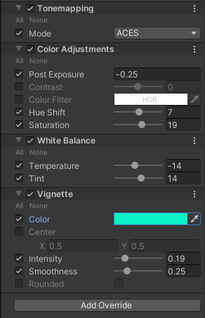

1. After post processing:

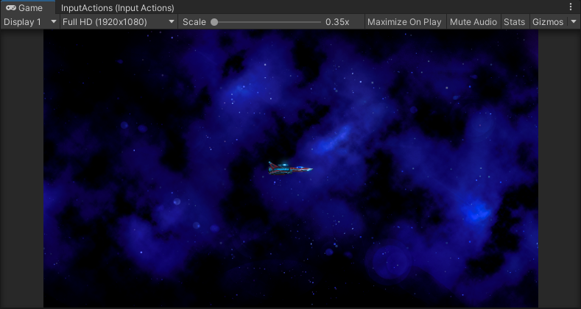

1. Create a projectile object, add bullet mesh and material to it

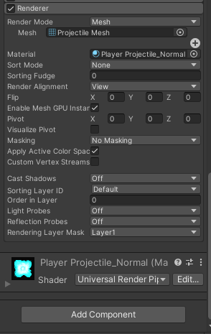

Change the start speed to 0, its speed will control by script

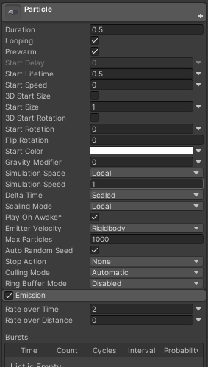

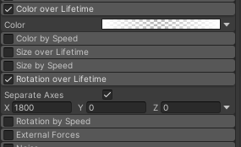

Change color and rotation by time

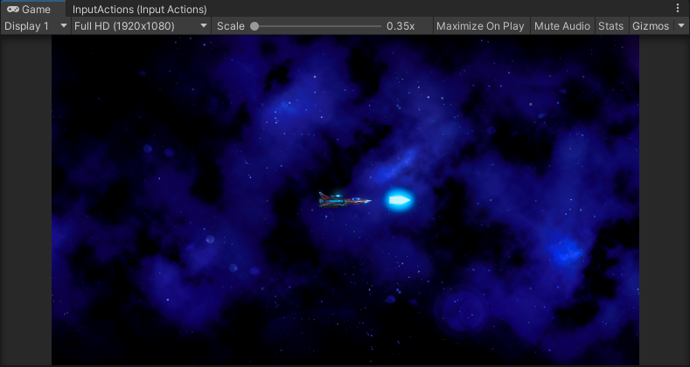

Add a trail to bullet

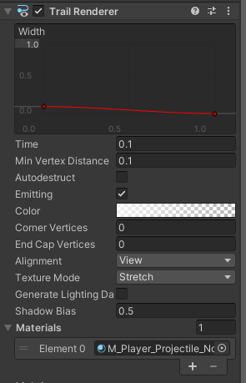

1. Create a projectile class, we have player projectile and enemy projectile, so we need to extend this class for player.

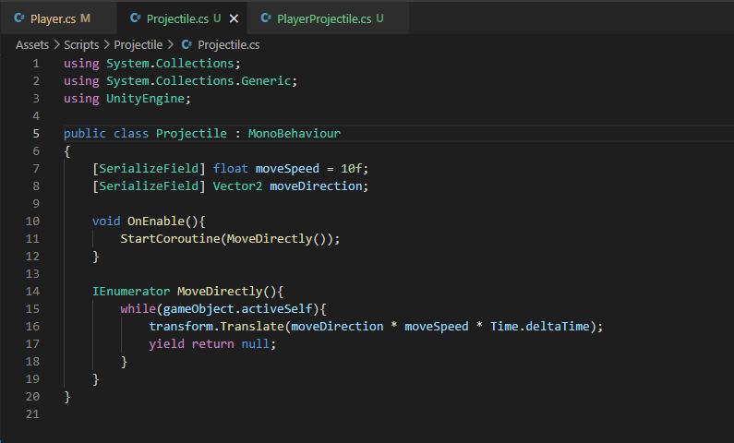

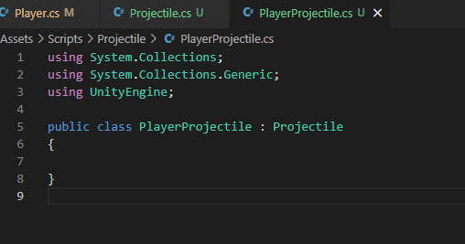

**Bullet shooting**

1. Add Fire to input system

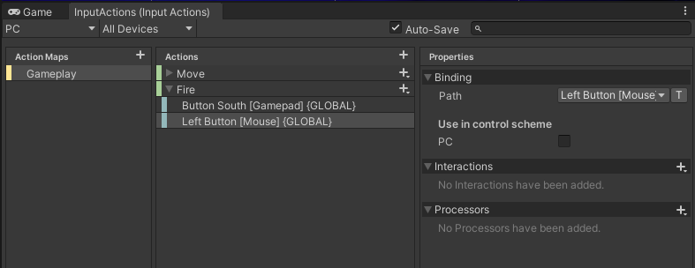

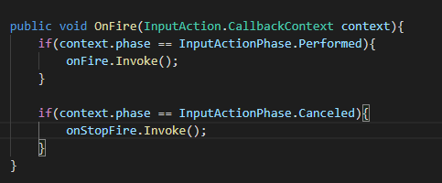

Add Fire and StopFire to OnEnable

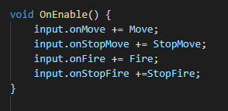

Create projectile object and muzzle object for player

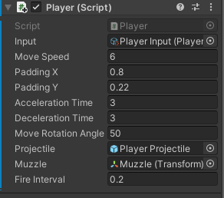

Add another script to auto destroy bullet after a lifttime

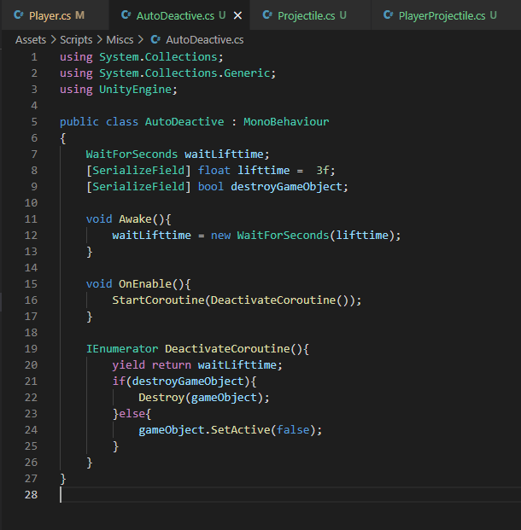

Use a coroutine to keep fire when press keyboard

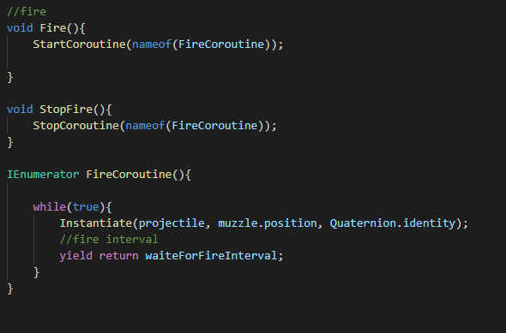

**Object pool**

Why object pool? Performance improvement, less GC

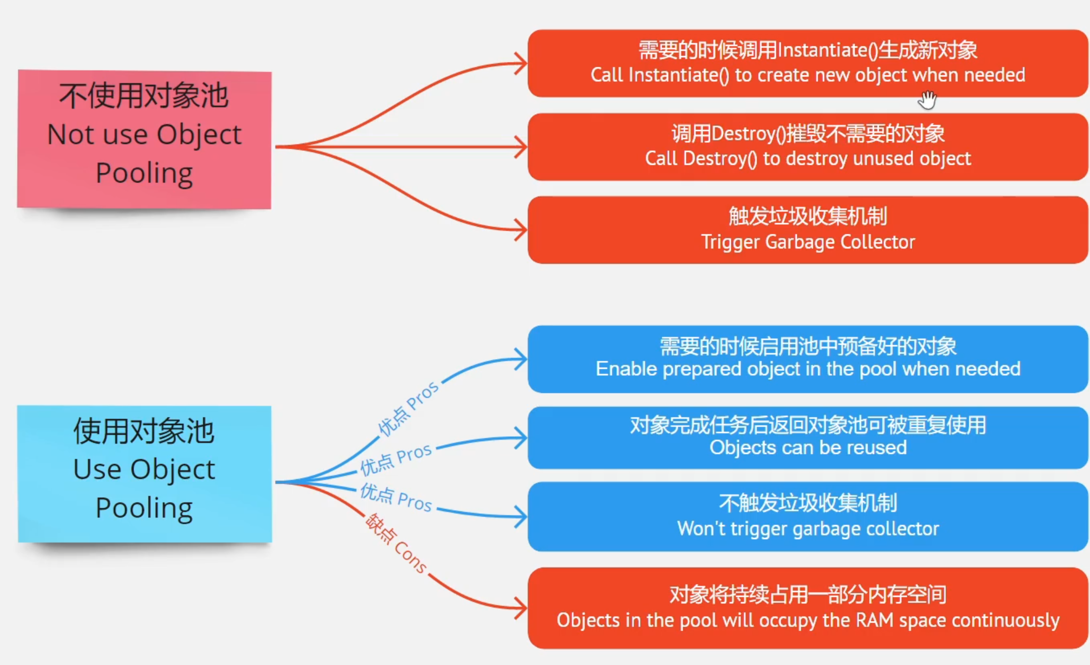

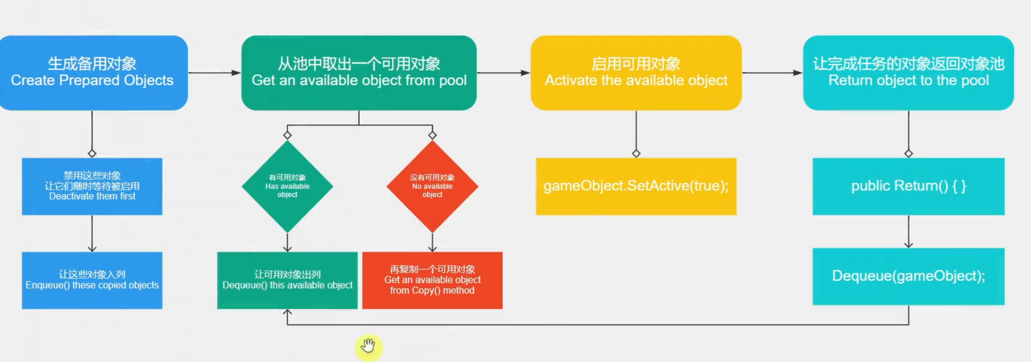

Create a pool class

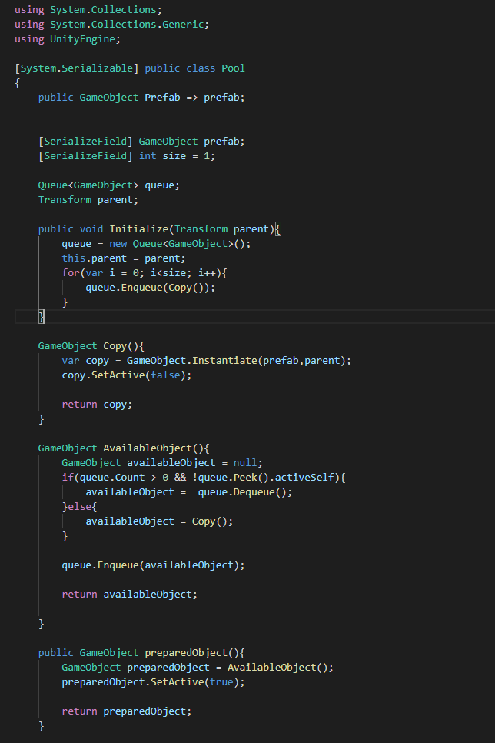

Create a pool manager with a array of pool

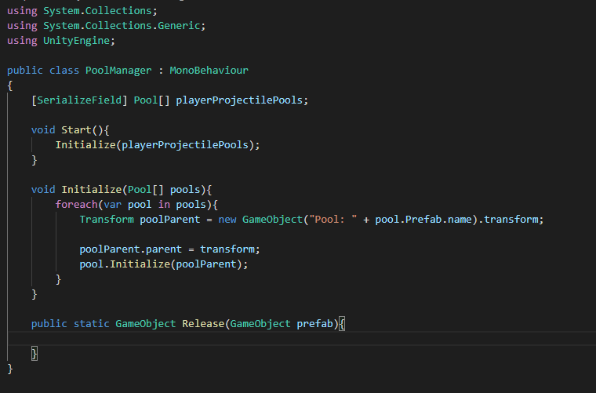

Create dictionary for more prefabs

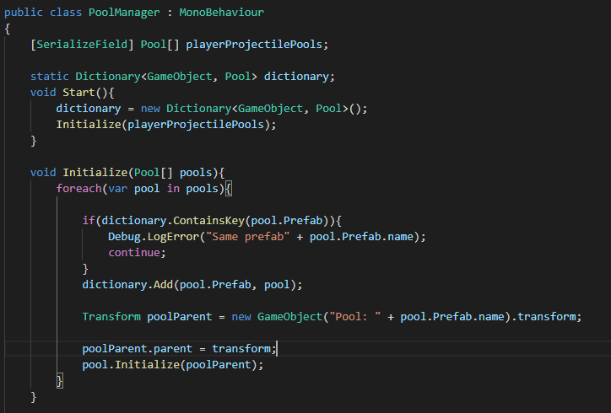

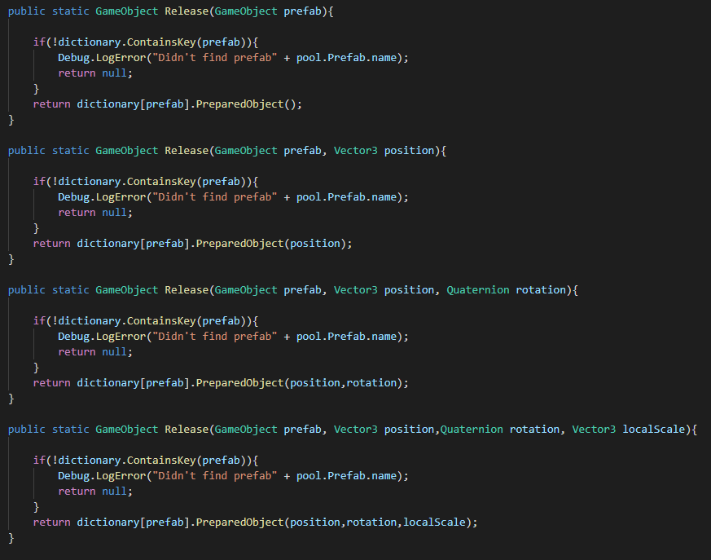

Create weapon power and more muzzle, more projectile

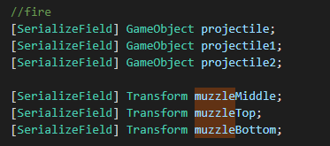

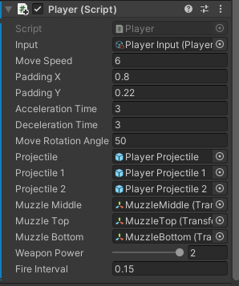

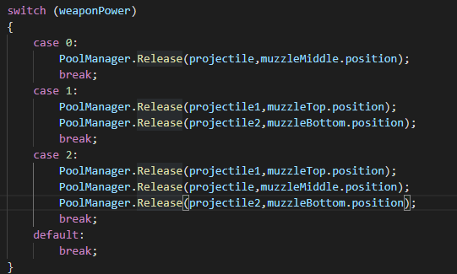

Now player can release more projectile!!

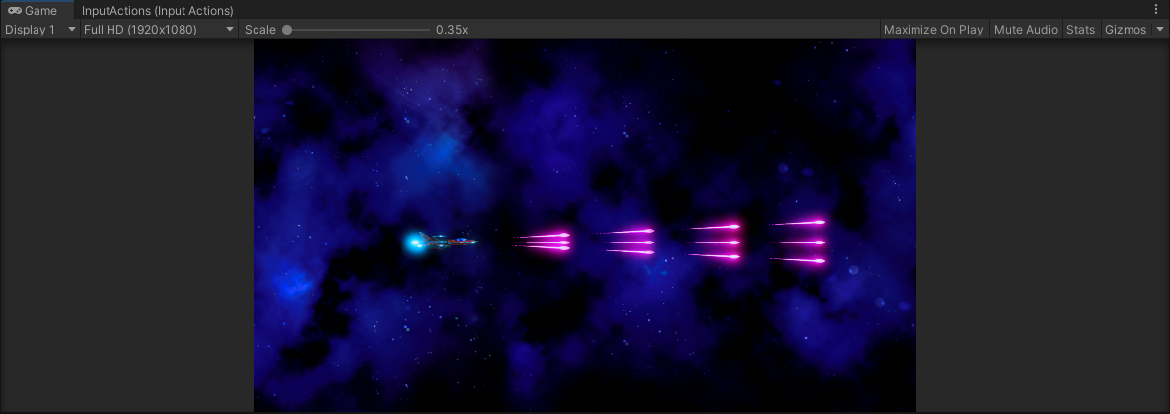

**Enemy**

Create function for enemy born point and moving range in view port

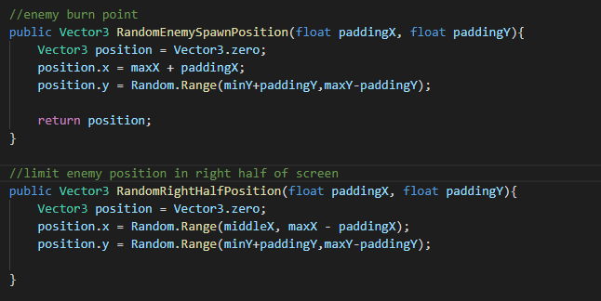

Create a controller for enemy, move function

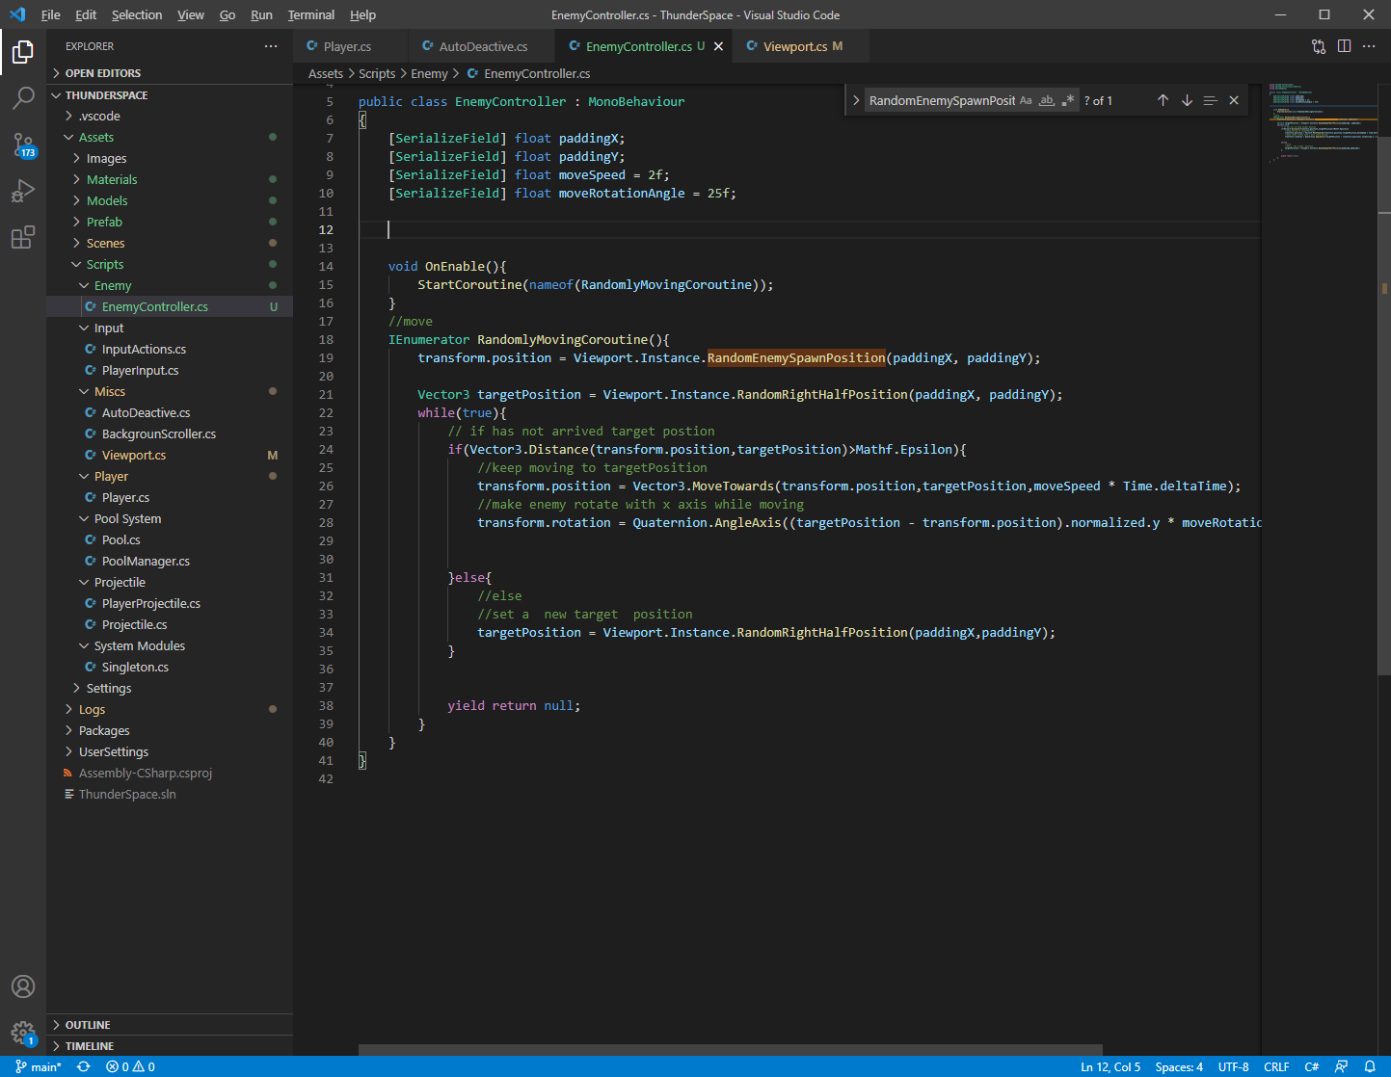

Enemy fire function

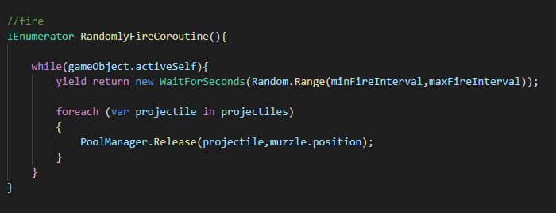

Add enemy projectile

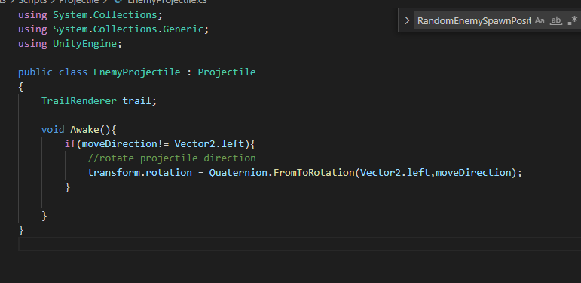

**Health System**

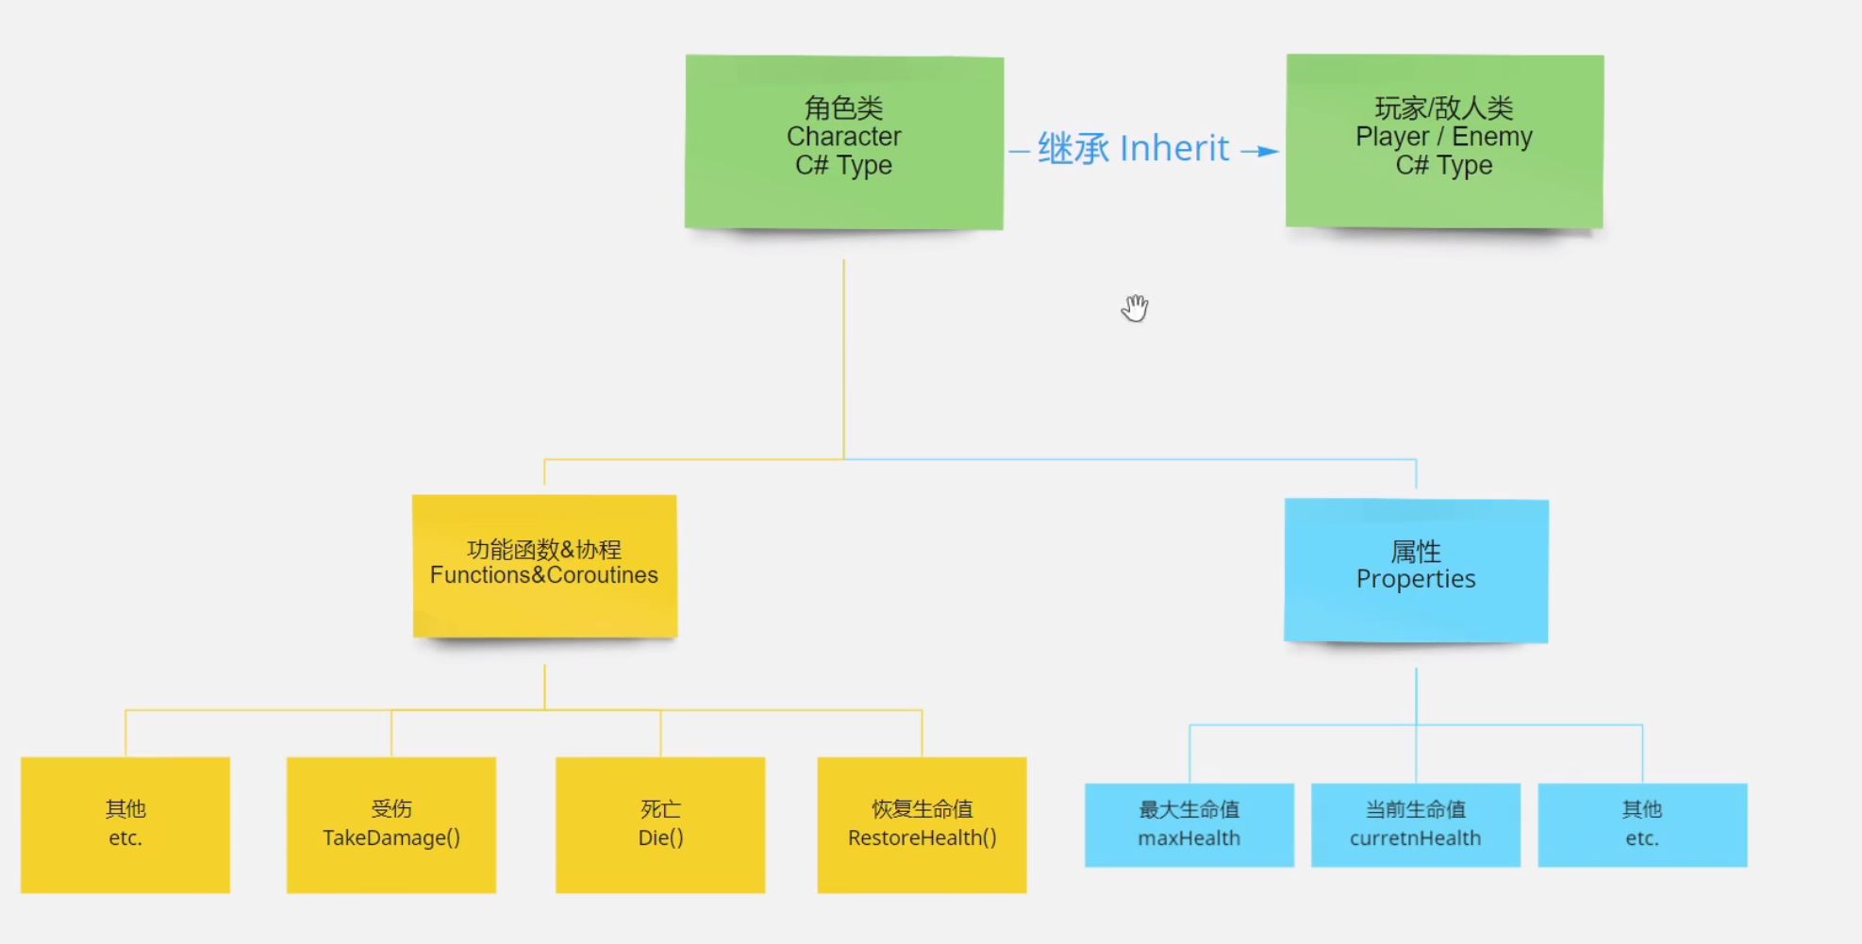

Create a Character class for player and enemy, it has take damage, restore health and die.

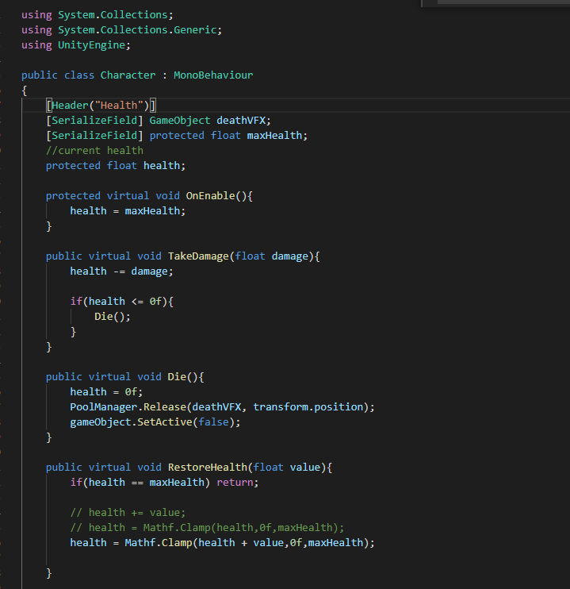Player can take damage by time  
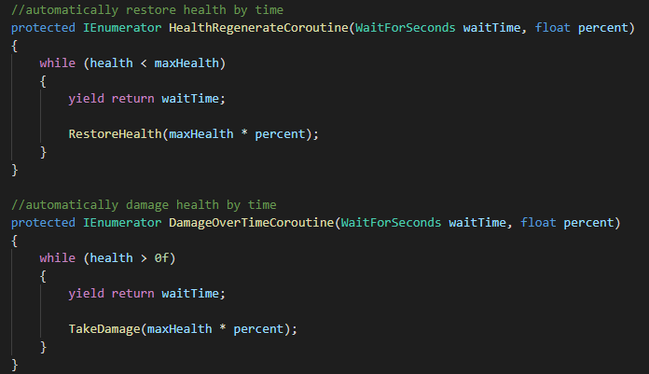

Create different Enemy Projectile

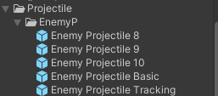

Tracking projectile which can track player

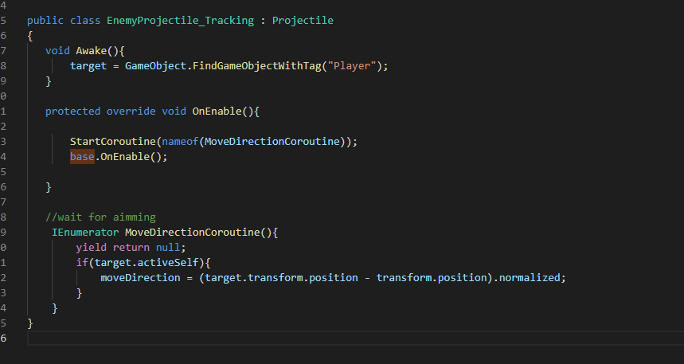

Other projectile has different mesh and directions

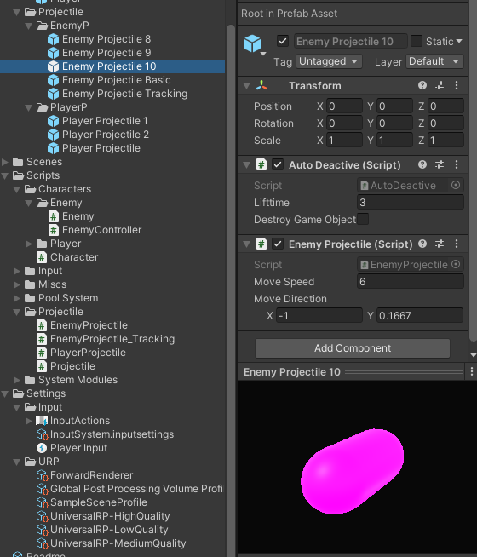

**Projectile hit characters(player and enemy)**

Create different layers for different objects:

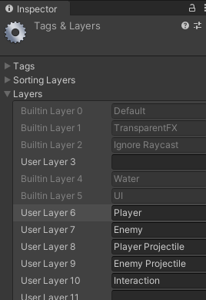

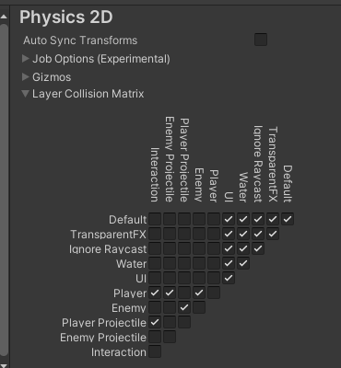

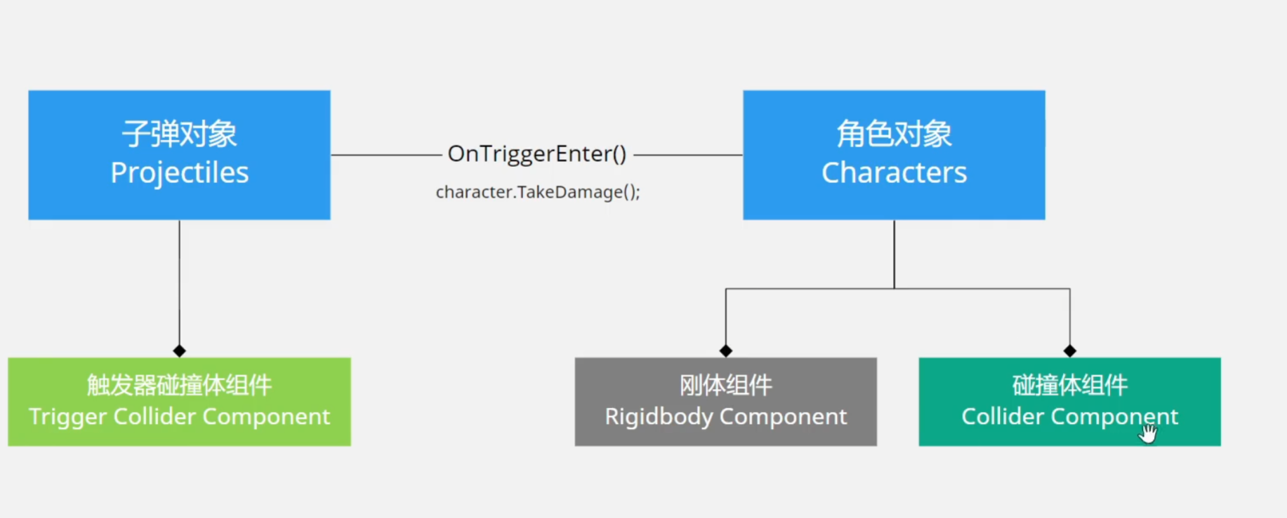

Add Collider to projectiles

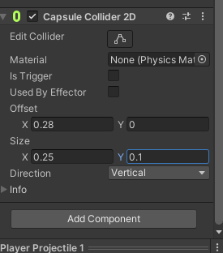

Turn enemy to rigidbody

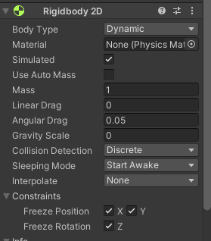

Add Collider 2D to enemy and player

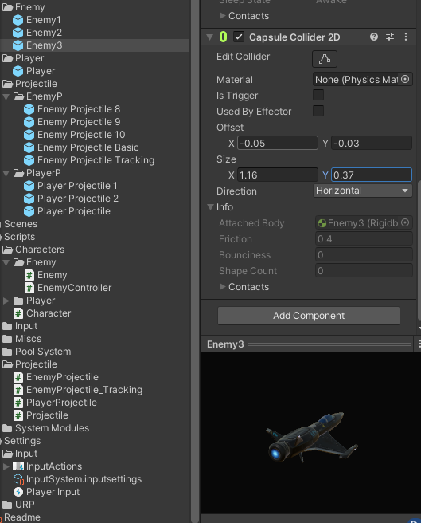

**Health bar**

Create UI canvas for health bar on head

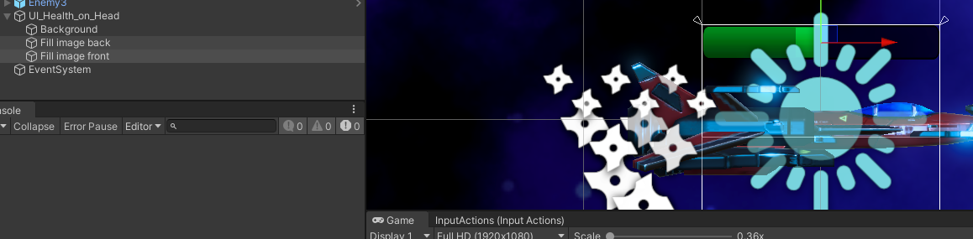

Create stats bar class for player and enemy

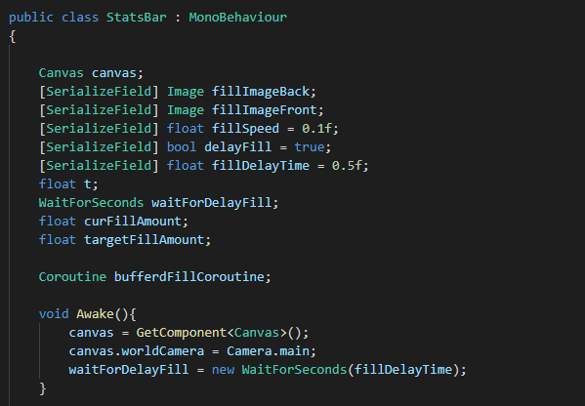

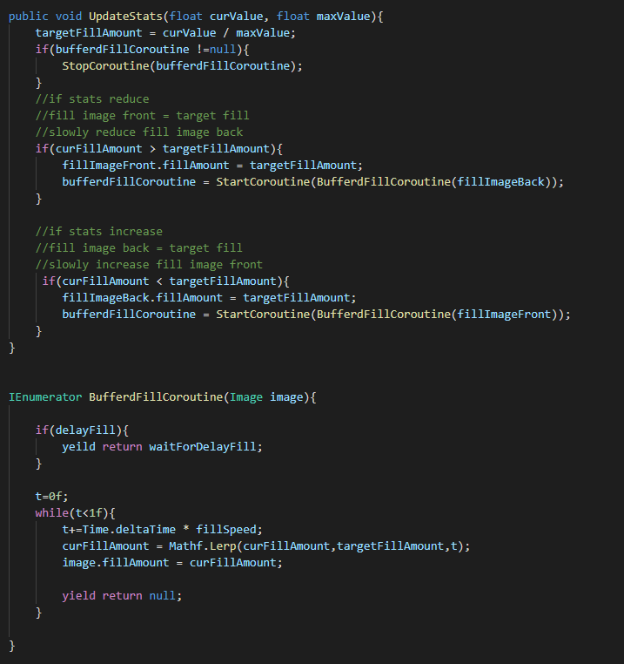

Add health bar to character

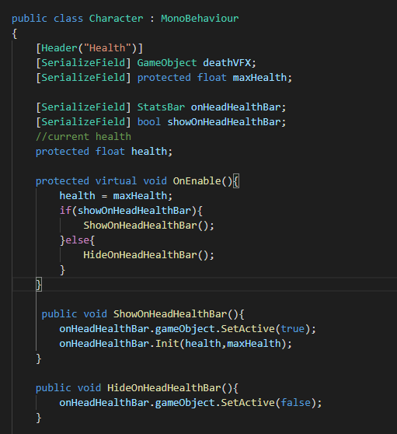

Create HUD Health Bar for player

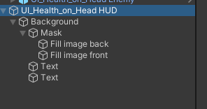

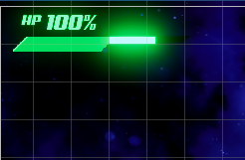

Create a HUD class extended stats bar class to update text in HUD bar

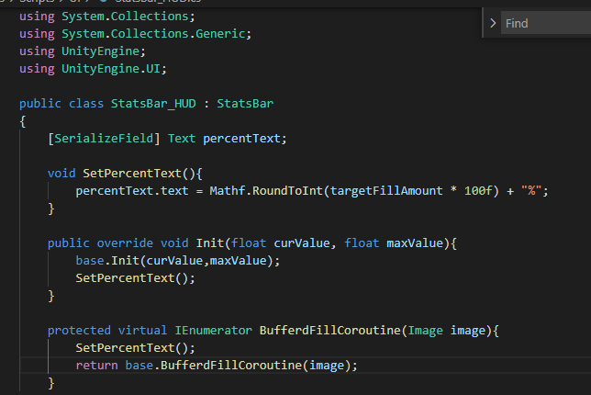

Now player has a cooler Health bar on top left!

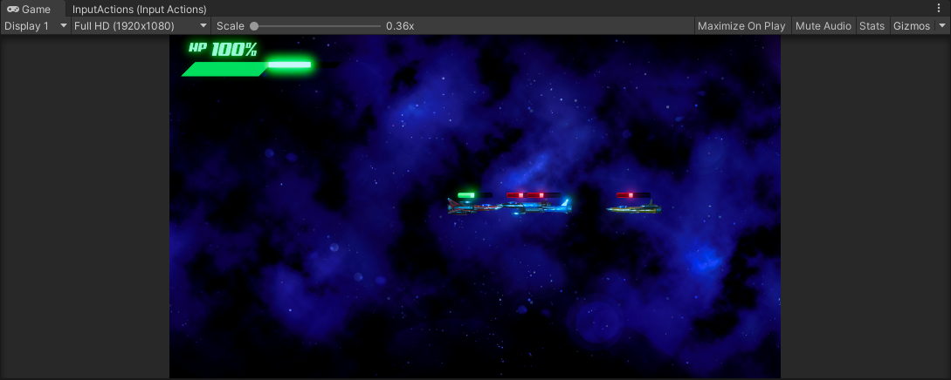

**Enemy Manger**

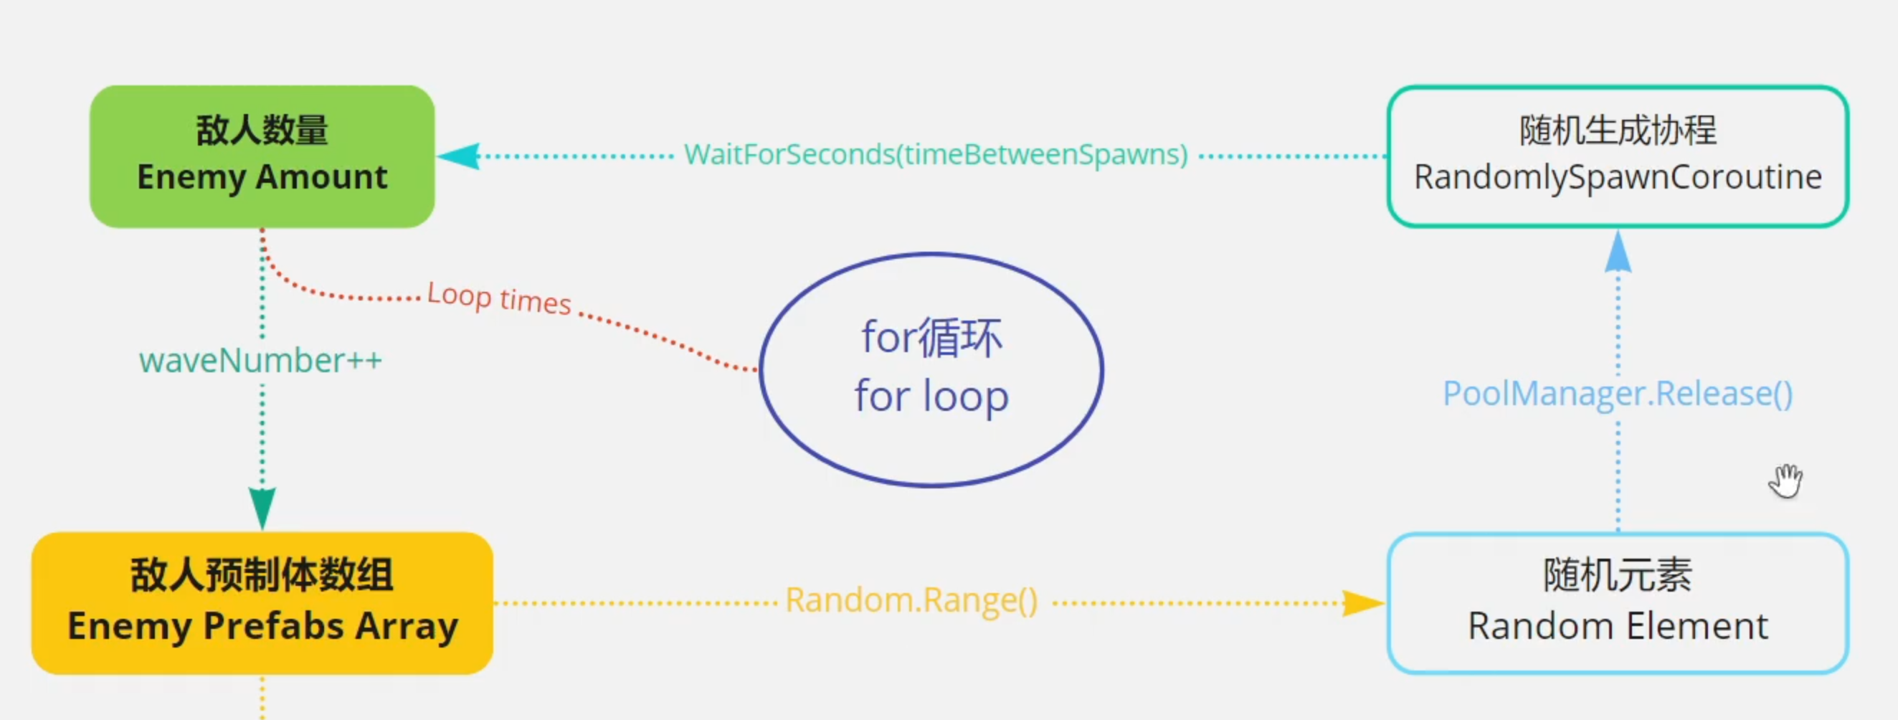

Create Enemy Manager, extend singleton, enemy reborn randomly by time

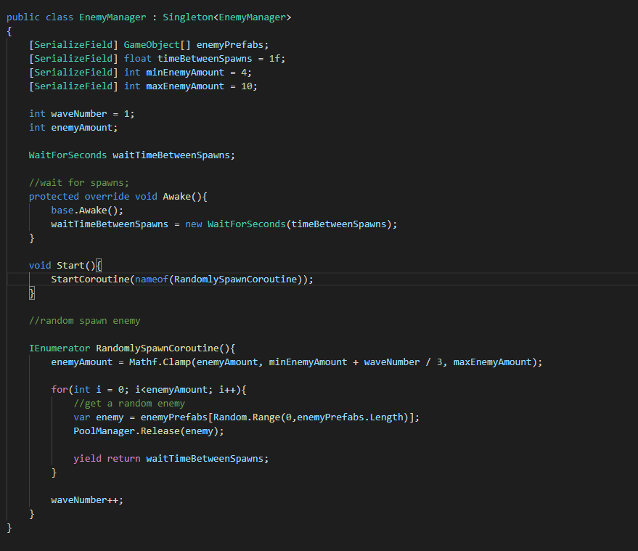

Reborn new enemy when there are no enemy in screen

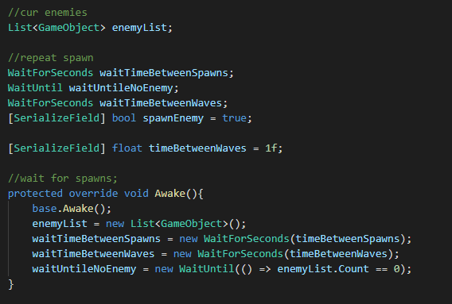

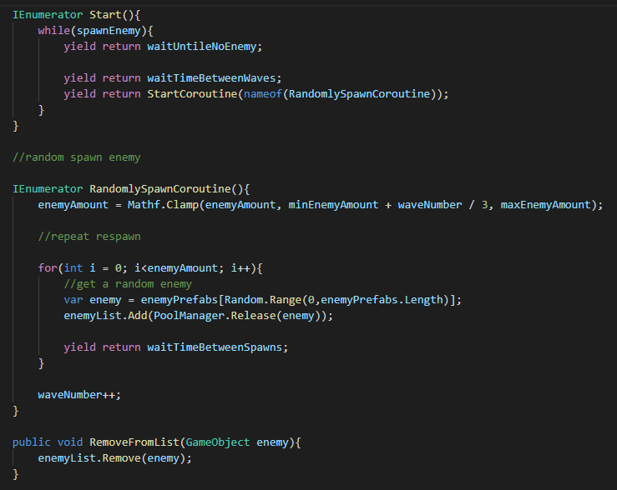

**Wave count UI**

Create a wave UI game object

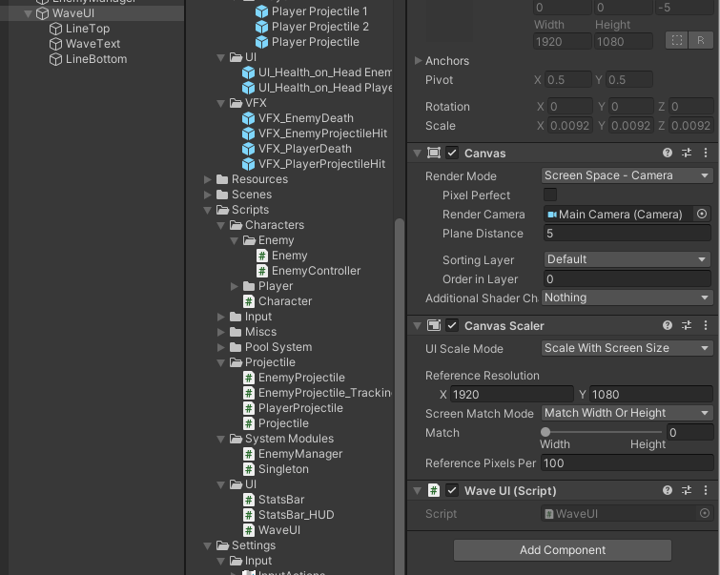

Add a script to get wave number

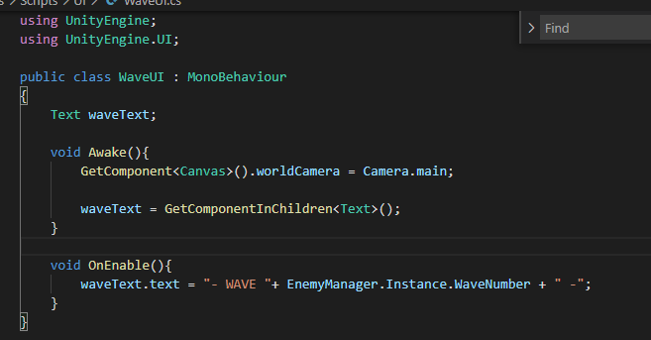

Create animation for wave UI

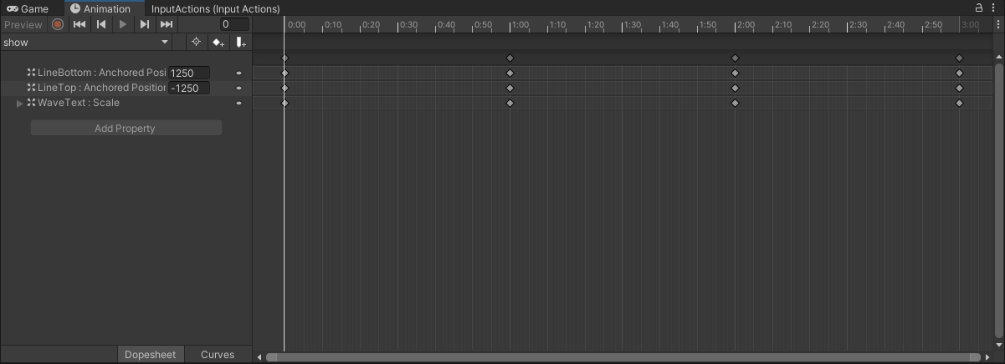

**SFX and Music**

Add a Audio manager to manage audios

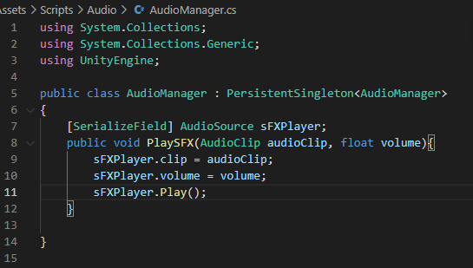

Add SFX for player, character, enemy and projectile

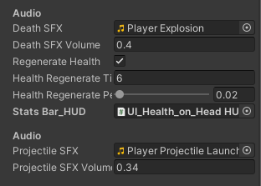

**Simple Main Menu**

Add a new scene called Main Menu

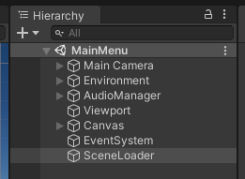

Add a button to it

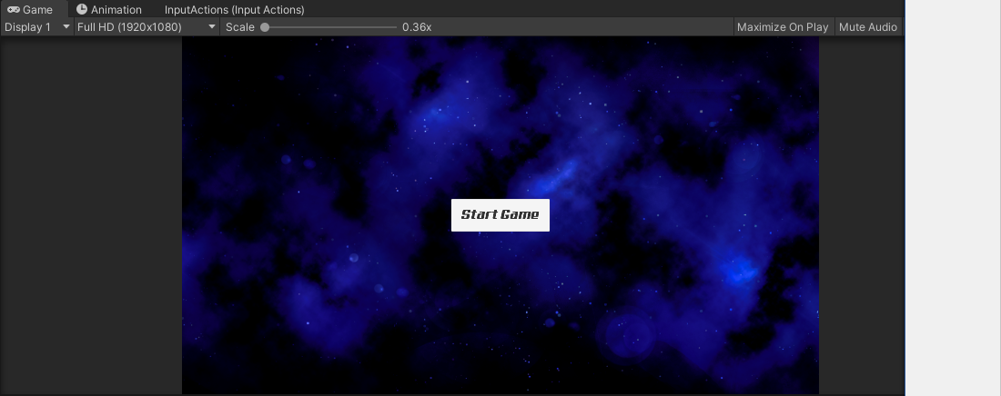

Create a sceneloader script

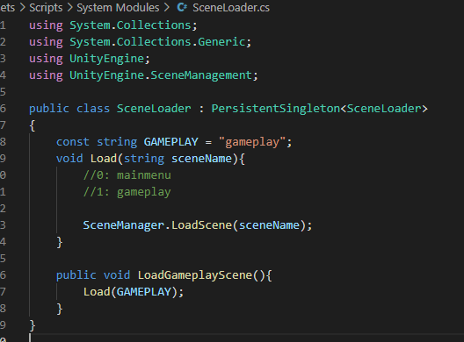

Add on click event to button

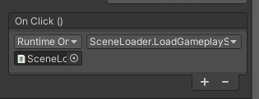

**Score System**

Add a score UI

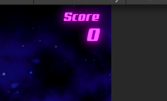

Add a scoremanager to manage score

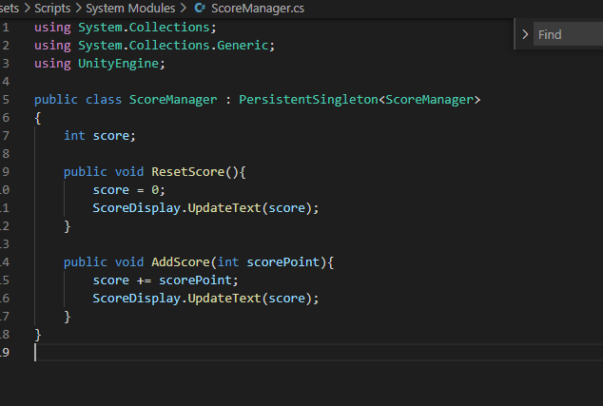

Add a script to update ui

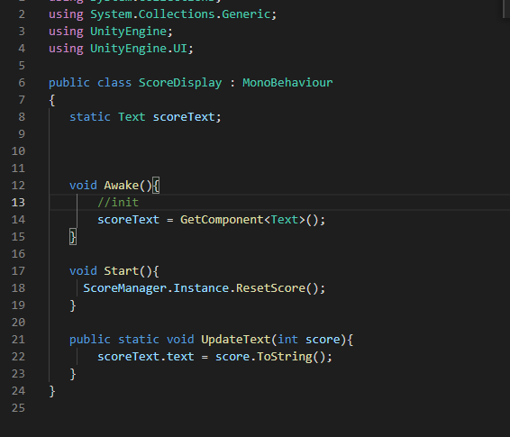

Actively increase score

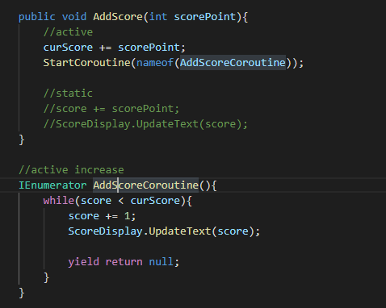

**Pause menu**

Add a pause menu UI

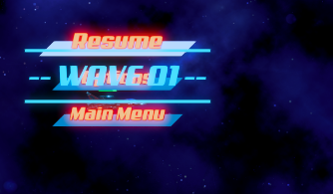

Add animator

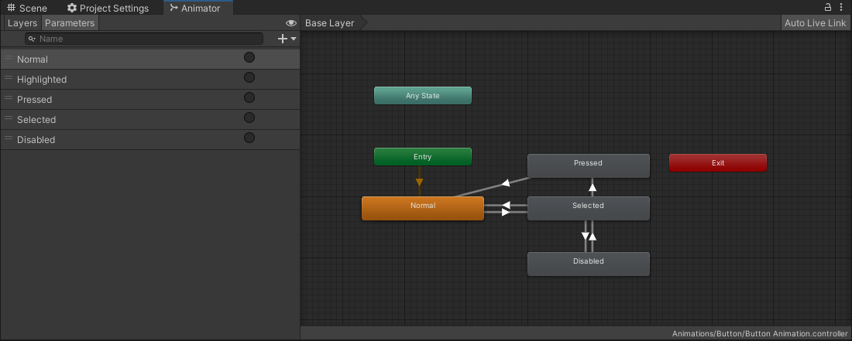

Add input action

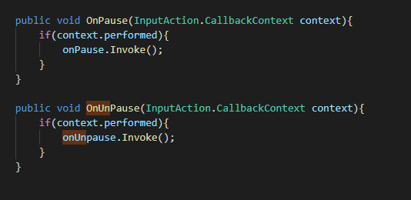

Add a game play controller to controll UI

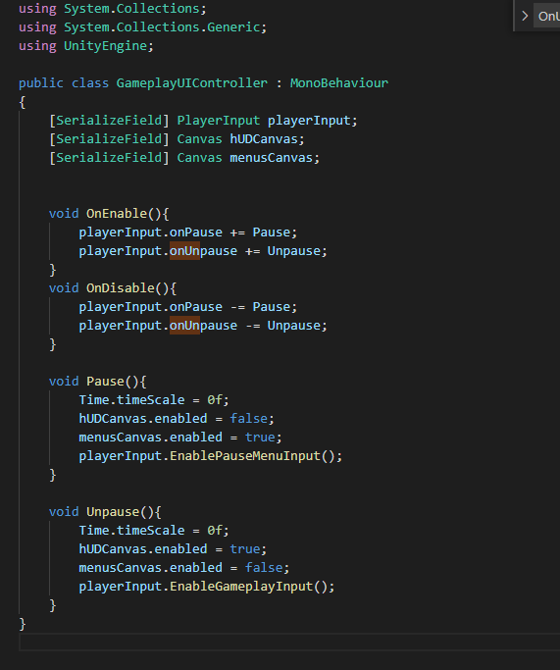

Switch input setting update mode to fix pause

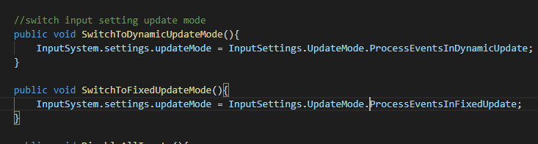

Add function to pause menu button

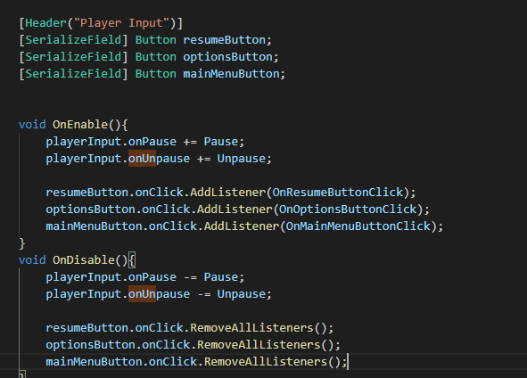

**Game manager**

add a game manager to manage game state

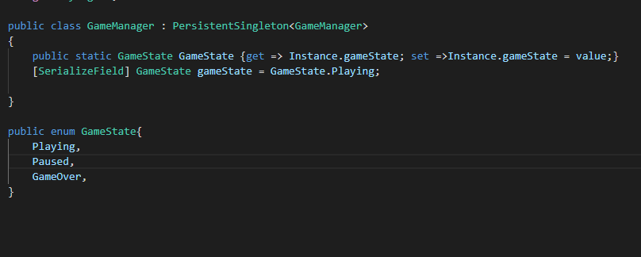

**Main Menu**

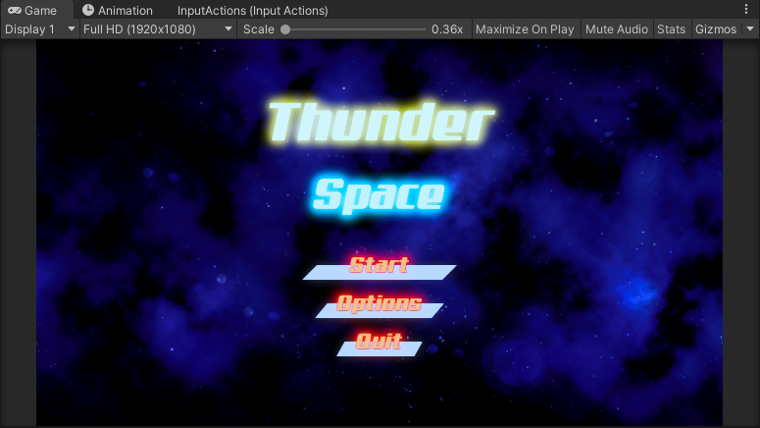

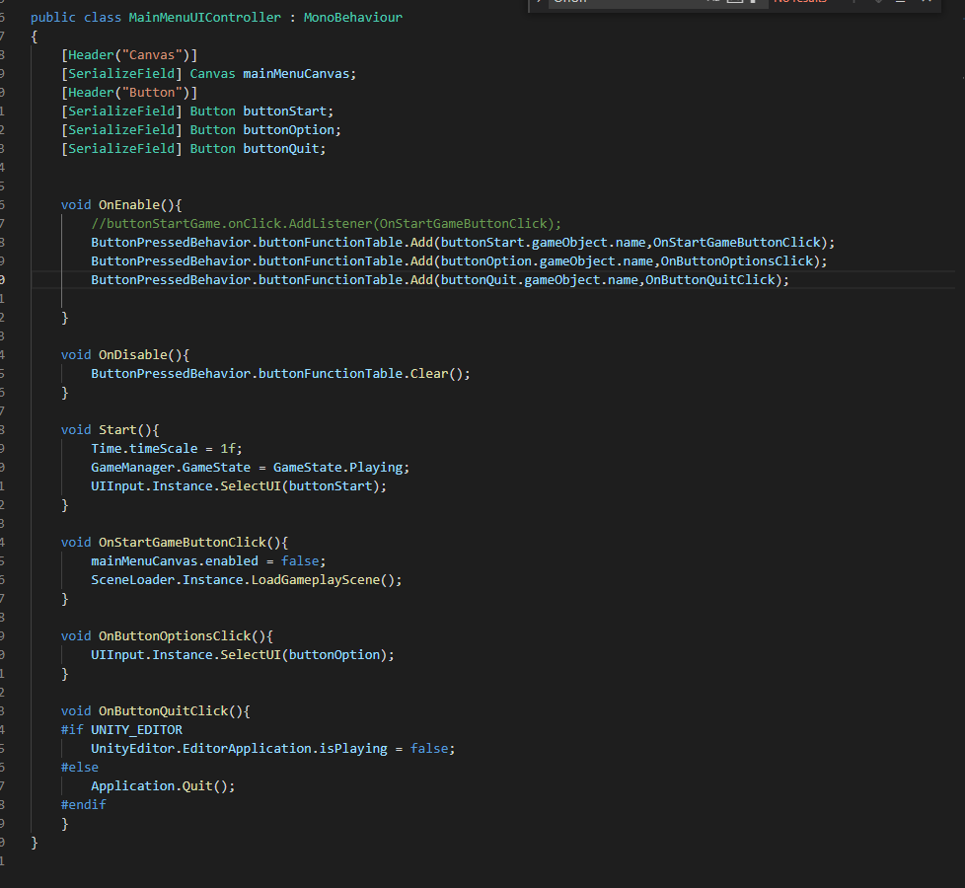

**Game Over Screen**

**Create a Game over UI**

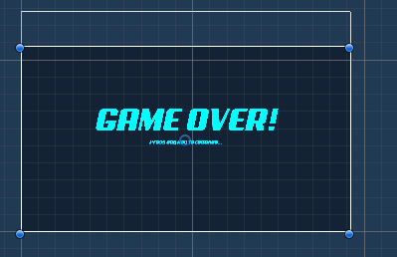

Add a script to control game over

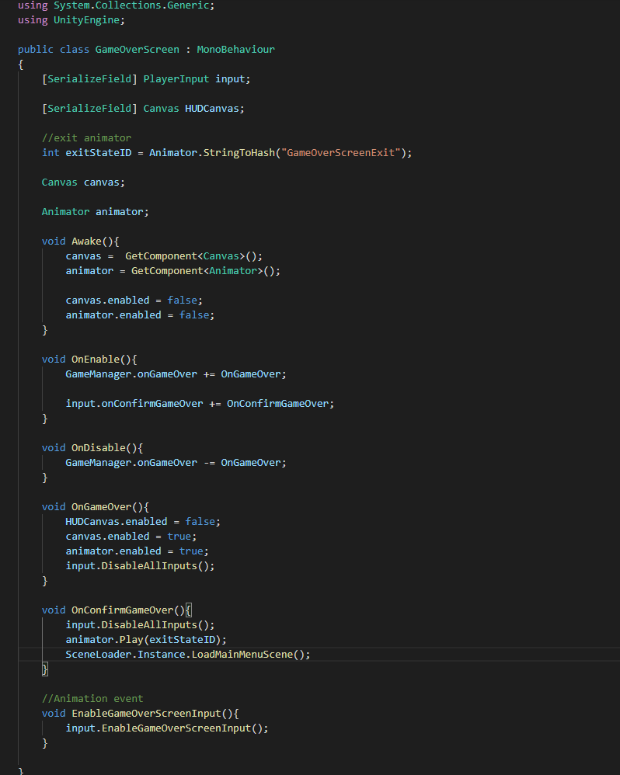

**Show and tell**

Hi everyone, this is a 2D side scroller shooter game.

Here is the main menu, our player is a space fighter on the left side, and enemies are on the right side. When I press start, the game will start. As you can see, the background is scrolling and player can move in screen and can't go out of screen. The enemies will born from right side of screen randomly.

It is a survival mode game, in which player try to live longer and get as more score as they can. Player will get score when they destroy enemy ships. Score will display on righttop of screen.

Enemy come with waves, I added a asimple animation for wave number. And their amount will increase by more and more waves. After clear one wave, Their will be a next wave with more random amount enemies.

Their are 3 types of enemies and they shoot different kind of projectile and have different health level and speed. the sphere projectile can track the player's position when ejected.

Also we can see a health bar of player on the top left of screen. When it goes to 0, the game is over. The health will reduce when player take damage. And the health will drop to 0 immdiately when crush to enemies. Enemies' health bar is on the top of enemies. Also I added a buffer to health bar. it can drop slowly with a buffered time. player's health can slower increase by time if health is lower than 100% every few seconds.

When I tap Tab, The game will pause and comes to a pause menu, in which player can resume game or go back to main menu.

When player die, I added a animation to show game is over and press any key, the player will go back to main menu. This is a game cycle. I will add more functions later like the pick ups, which can give player scores or more powerful weapon. Also the options menu, to edit BGM or game difficuty. So that's all for my project.